# MySQL Server Windows Installation Guidelines

This document consists of guidelines for installing MySQL server. The installation file for Windows can be downloaded from [here](https://dev.mysql.com/downloads/installer/).

### Step 1. Download MySQL Community Server

Go to the MySQL web site and download MySQL Community Server. The link given above should redirect you to the official MySQL webpage where you can find a link to downloading the MySQL Community Server Installer.

Click the “Download” button corresponding to your OS.

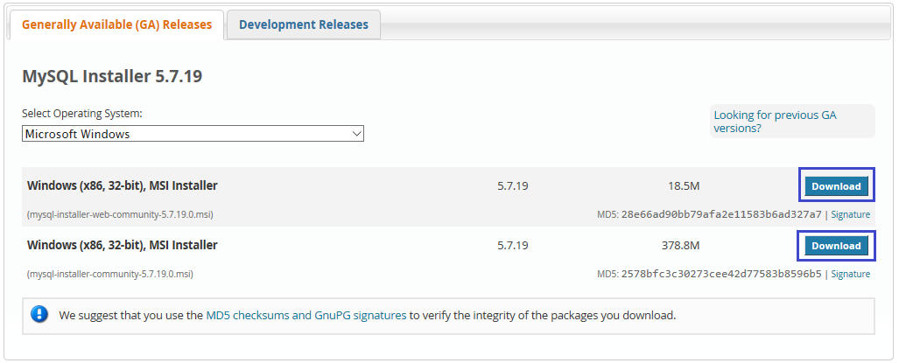

### Step 2. Install the MySQL Community Server

1. Open installation file and choose the **Setup type** to be **Custom**. Then click **Next.**

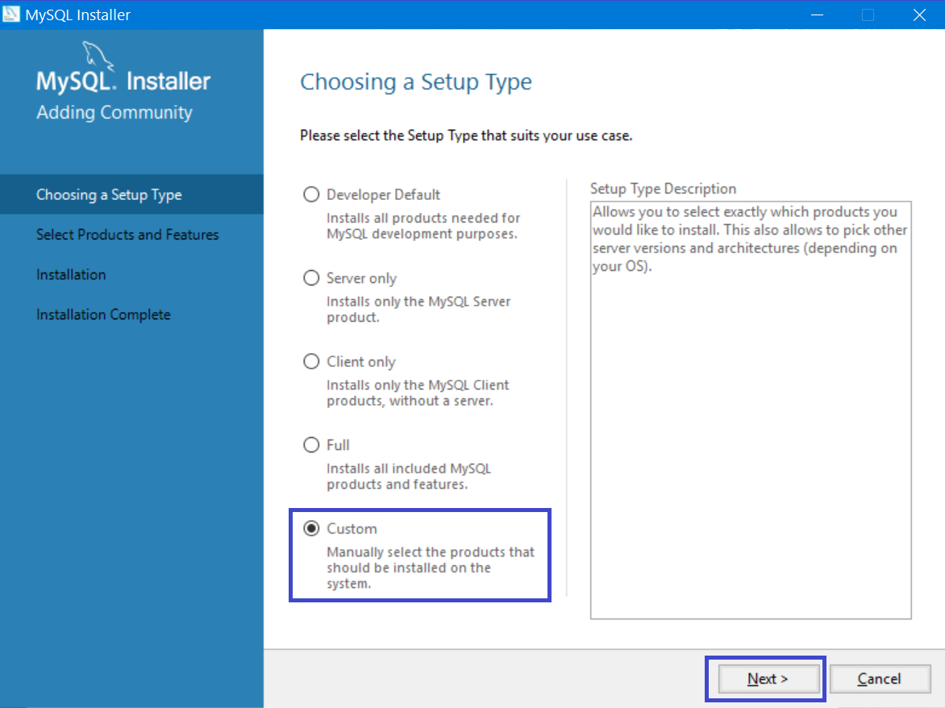

1. All the features we need are **MySQL Server**, **MySQL Workbench, Connector/J**, **Connector/NET and MySQL Workbench**. All other features are optional and won’t be needed for that course.

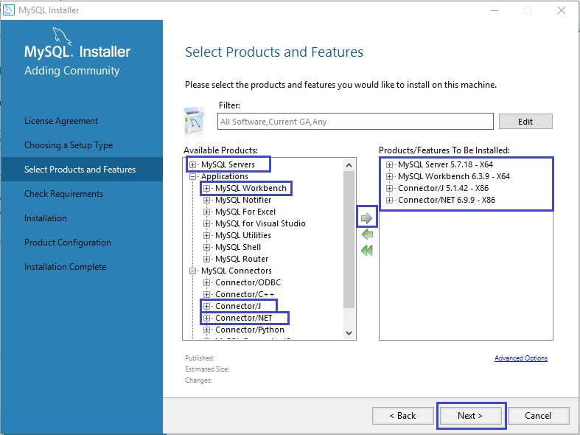

1. Just click **Execute** and the setup will install these features

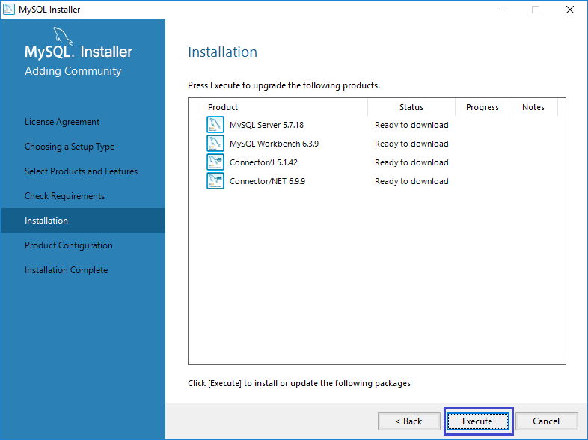

1. Choose the configuration type to be a **Development Machine** and click on Next.

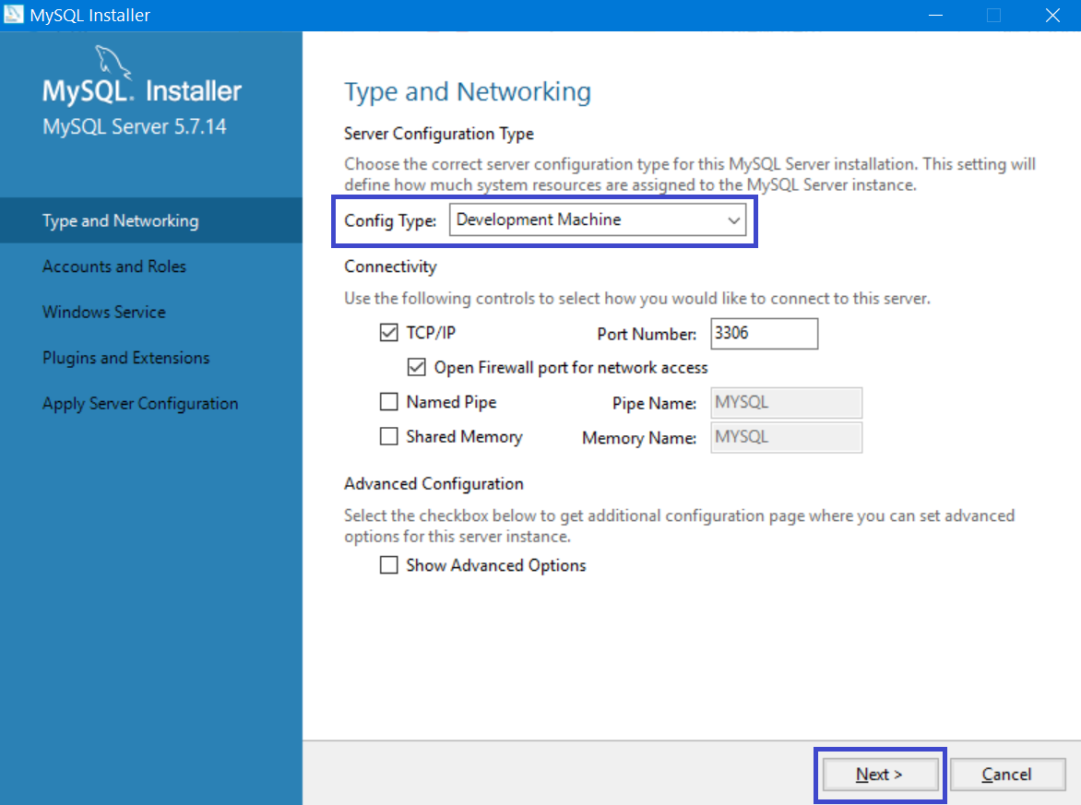

1. Set password to the Root account.

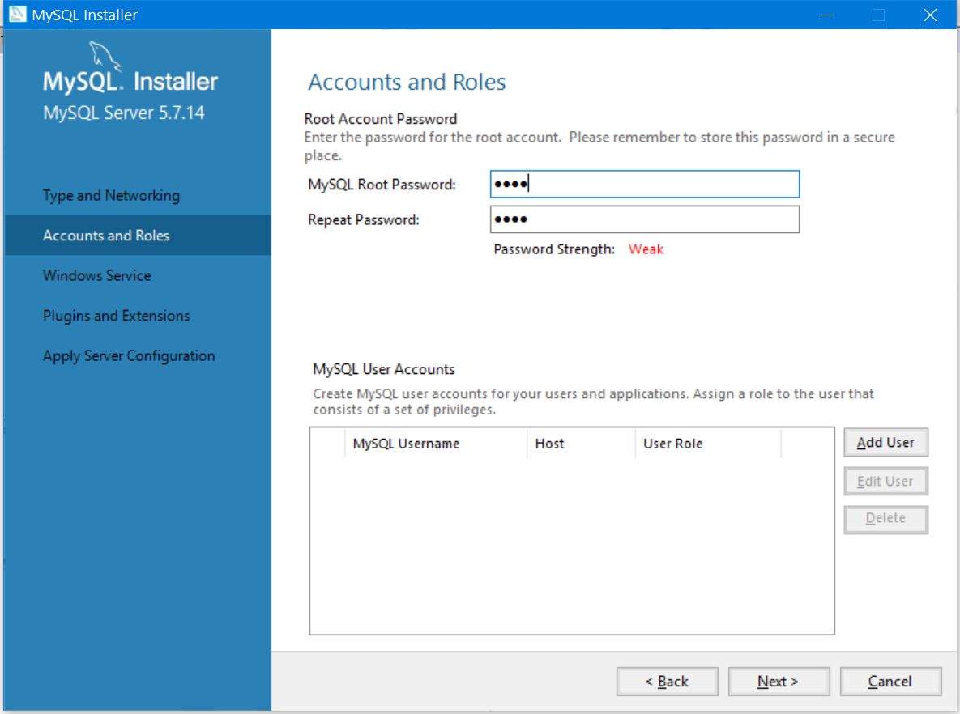

1. Here you can set the **MySQL Server** to run as **Windows Service** and to start automatically at Windows start up. This is the recommended way. Otherwise you must start up MySQL every time before working with the database.

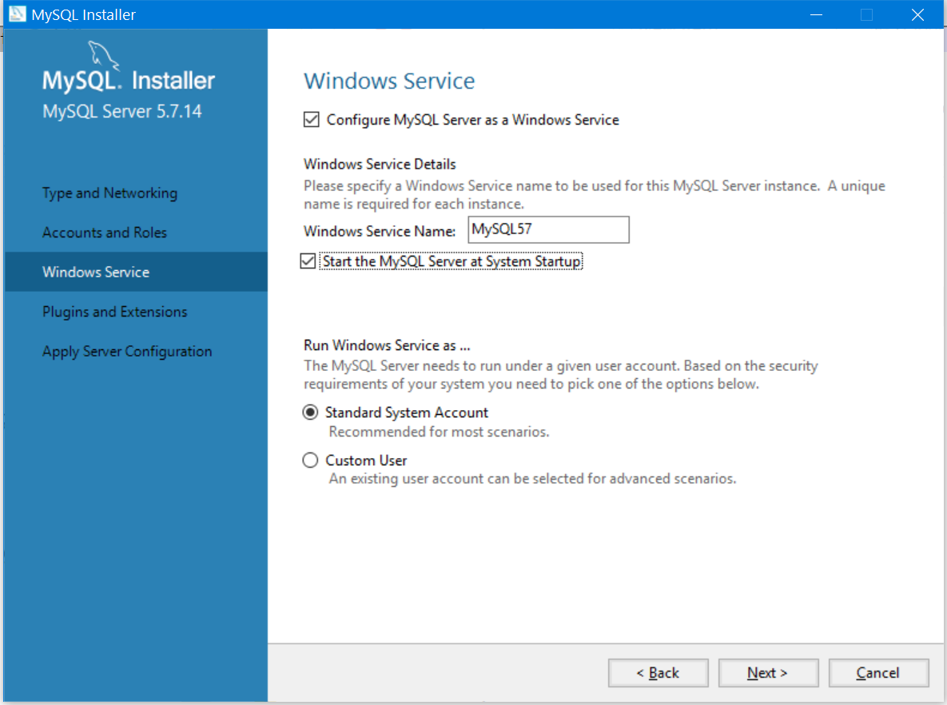

1. Click **Next >** to start the installation and wait until it finishes installing